Logistic regression

Full Dataset

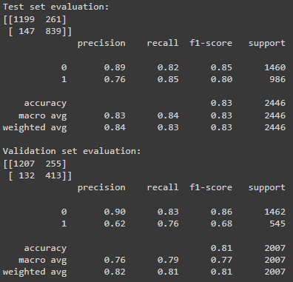

Without dummies and coordinates

Without profiles

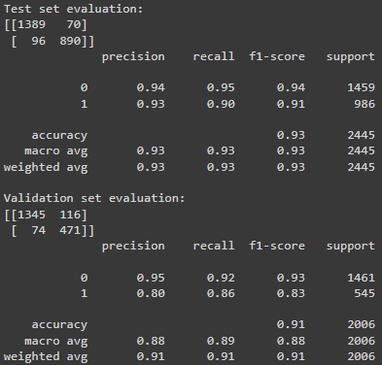

Random forest

Full Dataset

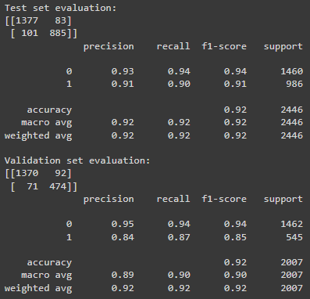

Without dummies and coordinates

Without profiles

Neural network

Full Dataset

Without dummies and coordinates

Without profiles

